USER MANUAL

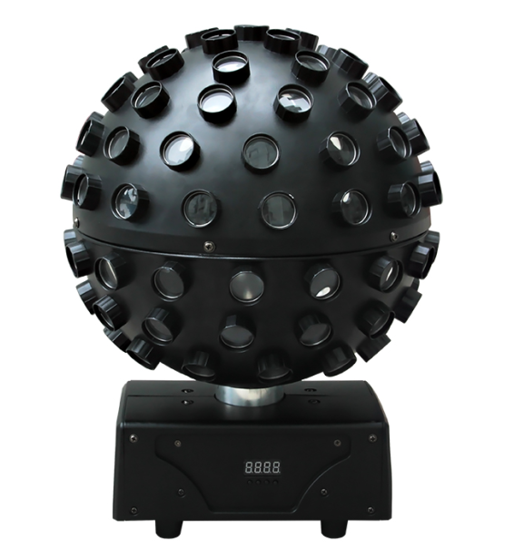

Please keep the manual carefully for future reference

Contents

Introduction & Caution--------------------------------------------P2

Silkscreen and safety instructions ---------------------------P3

Safety instruction and product specification--------------P4

Installation instruction---------------------------------------------P5

Specification & Menu operation--------------------------------P6

DMX512 table---------------------------------------------------------P7

DMX connection-----------------------------------------------------P8

DMX address setting ----------------------------------------------P9

Rigging----------------------------------------------------------------P10

Clearing and Maintenance--------------------------------------P11

warranty card--------------------------------------------------------P12

Introduction
Thank you for your patronage. We are confident that our excellent products and service can satisfy you. For your own safety, please read this user manual carefully before installing the device.
In order to install , operate, and maintain the lighting safety and correctly. We suggest that the installation and operation should be done by the verified technician and follow the instruction strictly.

Following spare parts are included with the fixture:
- One XLR DMX connection cable
- One quick lock handle
- One safety rope
- One use manual
- One power cable
Caution
Before leaving the factory, this device has passed strict inspection, functions stable and perfect packing. If this device will be operated in any way different to the one described in this manual, the product may suffer damages and the guarantee becomes void. Furthermore, any other operation may lead to dangers like short circuit, burns, electric shock, crash etc. If any technology changes of this manual, company do not notice in further and have interpretation.



CAUTION!

Keep this device away from rain and moisture!

Unplug mains lead before opening the housing!


Warning!

Damages caused by the disregard of this user manual are not subject to warranty. The dealer will not accept liability for any resulting defects or problems.

Symbol Instruction On The Device
………………………………………..…………… CE Compliant

…

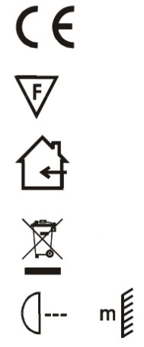
…Suitable directly installed on the common combustible materials devices

…

……………………………..………………………Only indoor use

…

……………………………………………Environmental protection
……

…

…...The minimum distance from fixture to the lighted objects(meter)

…

- Safety Instructions

CAUTION!

Be careful with your operations. With a dangerous voltage you will
suffer a dangerous electric shock when touching wires!
This device has left the factory in perfect condition. In order to maintain this condition and to ensure a safe operation, it is absolutely necessary for the user to follow the safety instructions and warning notes written in this user manual.
►If the device has been exposed to temperature changes due to environmental changes, do not switch it on immediately. The arising condensation could damage the device. Leave the device switched off until it has reached room temperature.
►Please make sure that the device be earthed.
►Please replace housing if it is broken. This fixture can be used after finished installed.
►The electric connection must carry out by qualified person.
►Make sure that the available voltage is not higher than stated at the end of this manual.
►Make sure the power cord is never crimped or damaged by sharp edges. If this would be the case, replacement of the cable must be done by an authorized dealer.
►If the external flexible cable or cord of this fixture is damaged, it shall be exclusively replaced by the manufacturer or his service agent or a similar qualified person in order to avoid a hazard.
►Please turn off the fixture if don't use in the fixture or want to clean, maintenance.

Please be aware that damages caused by manual modifications to the device are not subject to warranty. Keep away from non-professionals.
General Guidelines
►This device is a lighting effect for professional use on stages, in discotheques, theaters, etc., the device was designed for indoor use only.
►This fixture is only allowed to be operated with the max alternating current which stated in the technical specifications in the last page of this manual.
►The device can work continuously for eight hours. Lighting effects are not designed for permanent operation. Consistent operation breaks may ensure that the device will serve you for a long time without defects.
►Handle with care, do not make the device by strong shocks.
►While choosing the installation-spot, please make sure that the device is not exposed to extreme heat, moisture or dust. Please don't project the beam onto combustible substances.The minimum distance between light-output from the projector and the illuminated surface must be more than 1 meter.
►Please do not in damp, overheat or dusty environment install and use the device. Do not use light on fuel. The distance between the device and the projectile to keep at least 1 meter.
►If you use the quick lock cam in hanging up the fixture, please make sure the quick lock fasteners turned in the quick lock holes correctly,and add safety rope.
►Operate the device only after having familiarized with its functions. Do not permit operation by persons not qualified for operating the device. Most damages are the result of unprofessional operation.
►Please use the original packaging if the device is to be transported.
►For safety reasons, please be aware that all modifications on the device are forbidden.
►Any installation and maintenance must by professional person.
►If this device will be operated in any way different to the one described in this manual, the product may suffer damages and the guarantee becomes void. Furthermore, any other operation may lead to short-circuit, burns, electric shock, lamp explosion, crash, etc.

- Installation instruction
CAUTION!
Please consider the GB7000.15/EN60598-2-17 and the other respective national norms during
The installation. The installation must only be carried out by a qualified person.


►The applicable temperature for the lighting is between -25°C to 45°C. Do not use the lighting under or above the temperature.
►The installation of the effect has to be built and constructed in a way that it can hold 10 times the weight for 1 hour without any harming deformation.
►The installation must always be secured with a secondary safety attachment, e.g. an appropriate safety rope.Never stand directly below the device when mounting, removing or servicing the fixture.
►The operator has to make sure the safety relating and machine technical installations are approved
by an expert before taking the device into operation for the first time.
►These installations have to be approved by a skilled person once a year.
►Overhead mounting requires extensive experience, including among others
calculating working load limits, installation material being used, and periodic safety inspection of all installation material and the device. If you lack these qualifications, do not attempt the installation yourself. Improper installation can result in bodily injury.

3. Specification of the Device
●5pcs 15W RGBWY-UV LED with average 50000 hours lifespan ●beam angle：1º；beam spot angle：1º
●rapid scanning and endless rotation for Pan
●with SPFC power factor correction power supply, PF>0.99、efficiency > 90%
●electronic strobe at 1-25hz.
●color macros for choose
●IEC input/output, can link 20 units together.

4. MENU and display
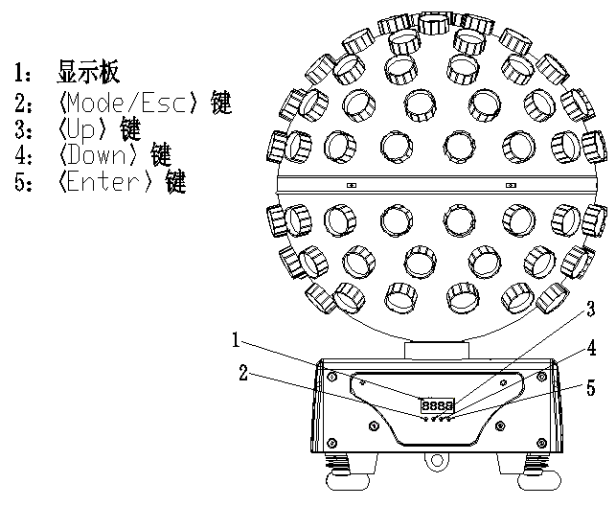
- LED Display
- MODE/ESC button
3．UP button（UP）
4．DOWN button（DOWN）
5. Enter button（ENTER）

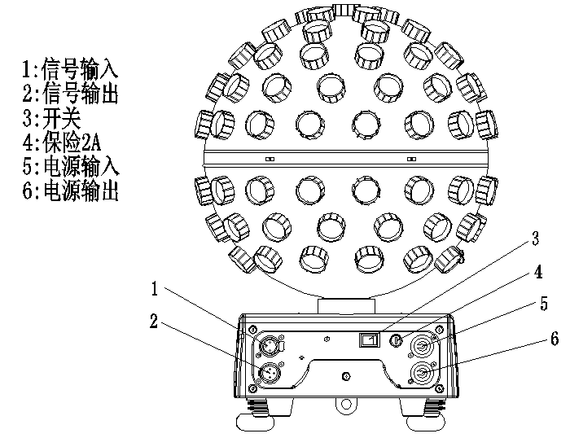
- Signal input
- Signal output
- ON/OFF switch
- Fuse 2A
- Power IN
6. Power Out

Menu operation
REST
REST

RESET

rdoF

rdoF

DISPLAYREVERSE OFF

rdon

DISPLAY REVERSE ON

A001
001-512

DMX mode

AuTo
Au0F

AUTO mode OFF
AuTo

AUTO mode ON

dFoF
dFoF

DEFAULT OFF
dFon

DEFAULT ON
SOND

SOUND mode

rdoF

rdoF

Sound sensitivity

ASTE

Mast

Master unit

Alon

Slave unit

Remarks:
1：When the display flickering slowly means the current MENU option, display flickering quickly means enters to set the data.
2：If no operation within 10 seconds, the menu will return to A001 display (the last 3 numbers mean the DMX address)

5. DMX table
CH | Value | Function
1 | 0-255 | Pan endless rotation
2 | 0-255 | 0-30 : no function  31-140：Pan endless clockwise rotation (from fast to slow)  141-145：stop rotation  146-255：pan endless anti-clockwise rotation (from slow to fast)
3 | 0-255 | Pan speed（invalid during endless rotation,226-235: light OFF when scanning，236-2255：max speed）
4 | 0-255 | Red dimming
5 | 0-255 | green dimming
6 | 0-255 | Blue dimming
7 | 0-255 | White dimming
8 | 0-255 | Yellow dimming
9 | 0-255 | Purple dimming
10 | 0-255 | 0-15: no function  Synchronous strobe：  16~95：strobe speed；  96~175：one time/second，OFF/ON proportion from low to high  Asynchronous strobe:176~255：Asynchronous strobe，strobe probability from high to low from 176-255
11 | 0-255 | master dimming
12 | 0-255 | 0-25: no function  26-205: each 20 values mean 1 color,  206-255：color changing（changing speed from fast to slow)
13 | 0-255 | Marcos as below：  0-55：no function  56-75：sound control，each sound will switch to next Marcos as below, sound sensitivity from low to high 40-80%  Remarks: this is not controlled by the sound sensitivity in MENU,the sound sensitivity setting in MENU is valid for sound function in Auto only  76-105：red，clockwise rotation  106-135：blue, anti-clockwise rotation  136-165：7 colors changing, clockwise rotation  166-195：7 colors changing, anti-clockwise rotation  196-225：7colors changing, with strobe（strobe 3seconds，light ON 7seconds），clockwise rotation  226-255：7 colors changing，with strobe（ strobe 3 seconds，light ON 7 seconds），anti-clockwise rotation

6. DMX-512 control connection

Connect the provided XLR cable to the male 3-pin XLR output of your controller and the other side to the female 3-pin XLR input of the light.You can chain multiple lights together through serial linking, the signal cable should have two core with shielded cable, the signal connectors are with XLR input and output connectors. Please refer to the below diagram:

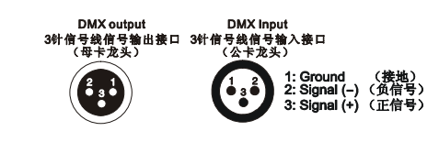

7. DMX address setting
Each fixture must set a specific starting address. When receiving signal, fixture will receive channel control signals of this address from the DMX controller.
For easy to use, the user can set the same address for several fixtures , also can set up a unique address for every device.
If you set the same address for all fixtures, all the fixtures will receive from the same DMX channels signal. All connecting fixtures are jointly controlled, controller can't separate control a device.
If you set a different address for each fixture, each fixture will receive unique signal and can be controlled by DMX controller separately.
This fixture has 12 channels.you should set the starting address of the first unit to 1, the second unit to 13(1*12 + 1), the third unit to 25 (2*12+ 1), and so on.

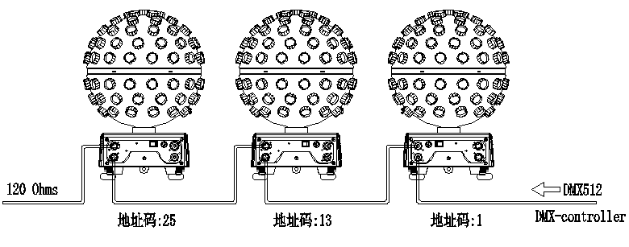

DMX-512 connection with DMX terminator
If there are many lines or lights, it is recommended to use a DMX terminator to prevent DMX signal corruption, the DMX terminator is an simple XLR plug with a 120 Ω resistor connected between pins 2 and 3,which is then plugged into the output XLR socket of the last fixture in the chain.
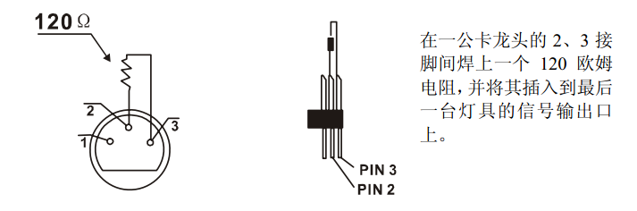
Welding a 120 ohm resistor between 2 and 3 pins male XLR , and insert it into the signal output of the last device

8.Information Error
Fixture will reset when turn on. If one or more channels have error, display will show“XX-ERR”,“XX” means PAN,TILT, Eg: displaying“PAN-ERR” means PAN RESET have problems. If both PAN and TILT error at the same time, display board will show“PAN-ERR”“TILT-ERR”. Fixture will reset all the time and not work as usual if appear one or more error. Please contact dealer or manufacture and let the experience person to maintain, do not open and maintain by user self.

9. Rigging:

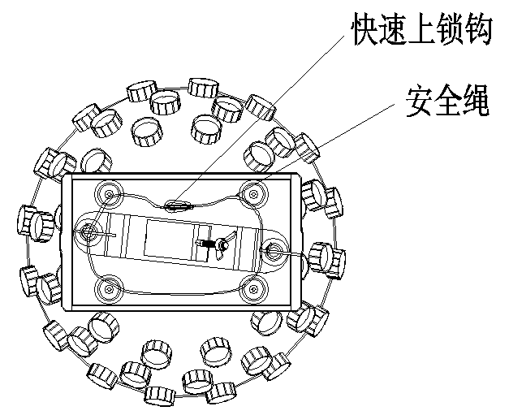
Safety-rope
Rapid locking hook

Insert the quick-lock fasteners of the first holder into the respective holes on the bottom of the device.Tighten the quick-lock fasteners fully clockwise.
Make the finished installed mounting bracket tighten on the fixed bracket.
Pull the safety rope through the holes on the bottom of the base and over the trussing system or other safe fixation spot.
Note:This step is quite important to ensure that fixture will not drop down for the damage of clamp.

10. Cleaning and maintenance
The following points have to be considered during the inspection:
- . All screws of the device have to be tightly connected and must not be corroded.
- .There must not be any deformation on housings, fixations and installation spots(ceiling, suspension,trussing).
- .Mechanically moving parts like axles,eyes and others must not show any traces of wearing (eg: material abrading or damages)and must not rotate with unbalances.
- .The electric power supply cables must not show any damages,material fatigue(eg: porous cables) or sediments.
5). Please use wet cloth to clean the housing. Glass cleaning liquid is suitable, never use alcohol or solvents!

Further instructions have to be adhered by a skilled installer to prevent any safety problems.

The cooling-fan should be cleaned monthly. The interior of the fixture should be cleaned at least annually using a vacuum-cleaner or an air-jet.

There are no serviceable parts inside the device. Maintenance and service operations are only to be carried out by authorized dealers.

11. Main technical data：
INPUT VOLTAGE：AC100 ~240V 50/60HZ
LED:TX-BGRWIY10B120-001, 15W/LED
POWER CONSUMPTION：55W
N.W.：3.65KG
CARTON SIZE:35.5*35.5*48.5CM

This product is made of high-brightness transistor. We will provide 1 year warranty under the condition that user has operated the light normally and lifetime service. We won't provide warranty if the damage is caused by artificial or force majeure event. Cost of fittings should be charged by user if product need maintenance after 1 year .Please cut this warranty card and shipped it along with the product to our factory when applying for warranty.
Product： Purchasing date： Code of invoice：
Warranty date: From To
User’s name： Add：
Company： Tel：
Warranty Card

